1. Introduction

A set of sample files is provided with the PMUUncertainty tool. Once the PMUUncertainty tool has been installed, the sample files will be found in the My Documents folder of the windows account who installed the tools. The files are in ..\My Documents\PMU Uncertainty\Sample Files.zip. These files should be extracted to use them to practice using the PMU Uncertainty tools.

Once a PMU has been fully calibrated by a PMU calibration system, determination of the calibration uncertainties and the Pass/Fail or Indeterminate status of the measurements is done using the PMUUncertainty.exe tool. The PMU calibration uncertainty and test status is performed in four parts:

1. Loading of the PMU calibrator uncertainties and the test limits for all PMU configurations (automatic)
2. Calculation of the Steady State and Dynamic test uncertainties not including the step tests
3. Calculation of the step tests uncertainties
4. Calculation of the uncertainties of tests at temperatures of 50 C and 0 C
5. Saving of the PASS/FAIL/INDETERMINATE (PFI) reports to an Excel file.
6. Optionally, the PMU calibration uncertainties and Test Uncertainty Ratios for all PMU configurations can be saved to an Excel file.
   1. PMU configuration

The PMU configuration is a combination of PMU settings for:

1. Nominal Frequency (F0)
2. Reporting Rate (Fs)
3. Class (M or P)

The PMU standard requires that PMUs support 18 different configurations of F0, Fs, and class, so there will be 18 full sets of test results and 18 sets of report spreadsheet data which will be used to generate a single PMU test report document. For each nominal frequency (50 Hz or 60 Hz) there will be both classes (M and P), and 3 reporting rates for F0 = 50 Hz: (10, 25, 50 FPS) and 6 reporting rates for F0 = 60Hz (10, 12, 15, 20, 30, 60 FPS)

1. Folder structure

Because the PMUUncertainty tools are automated, the folder structure under which these files are stored is important. The PMUUncertainty tools assume the folders are organized within a common “root” folder. The root folder name is typically a nickname for the PMU under test and is often found under the PMU Test system’s folder (but does not need to be there). A typical folder structure might look something like this:

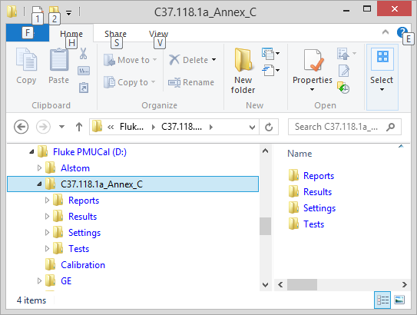

Figure : Typical PMU test folder structure

* 1. Reports Folder

Before you begin using the PMU Uncertainty tools, the Reports folder will be fully populated with the summary data spreadsheets, there will be six spreadsheets per PMU Configuration:

1. xxF0_nnFs_c.xlsx: The full summary spreadsheet containing all the tables which will go into the report document where xx is the PMU configuration nominal frequency, nn is the reporting rate and c is the class (M or P). This file contains tabs containing the tables and charts which will link into the final report document. The charts will need some manual adjustment of their axis ranges in MS Excel,. See section 4.1 Summary Results Spreadsheets
2. xxF0_nnFs_c_Ramp.xlsx: contains charts of the Frequency Ramp test results. These charts will need some manual formatting in MS Excel.
3. xxF0_nnFs_c_Phase_Step.xlsx contains charts of the Phase Step test results. These charts will need some manual formatting in MS Excel.
4. xxF0_nnFs_c_Mag_Step.xlsx contains charts of the Phase Step test results. These charts will need some manual formatting in MS Excel
5. xxF0_nnFs_c_0C.xlsx: Same as the full summary spread sheet but only containing the results of the frequency range tests at 0C
6. xxF0_nnFs_c_50C.xlsx: Same as the full summary spread sheet but only containing the results of the frequency range tests at 50C

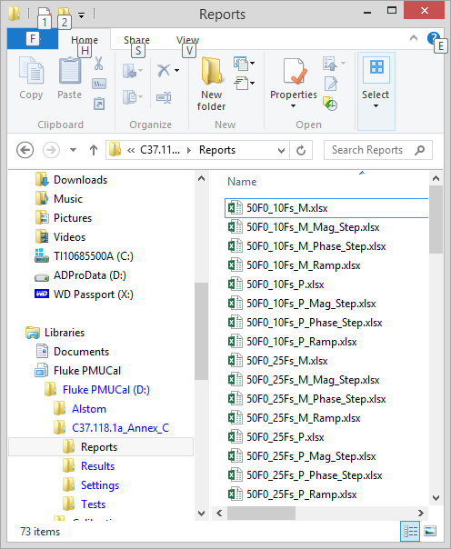

Figure : Reports spreadsheets

* 1. Settings Folder

The settings folder will be where the PMU calibration system uncertainty data is found by the program

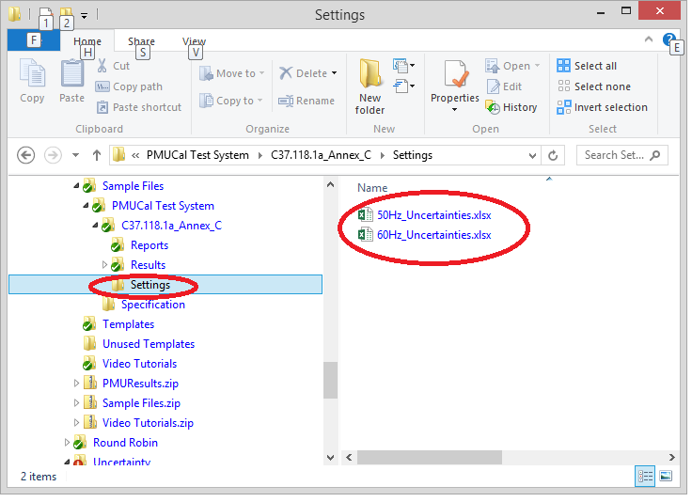

Figure : Settings folder including PMU Cal system uncertainty data

There are two PMU cal system uncertainty data files:

50Hz_Uncertainties.xlxs is the PMU calibration system uncertainty data at 50 Hz nominal frequency.  
60Hz_Uncertainties.xlxs is the PMU calibration system uncertainty data at 60 Hz nominal frequency.

Both of these files must be located in the Settings folder before the PMUCalUncertainty.exe program is started. If the folder or file is not found by the program, there will be an opportunity to place them there and retry. finding them.

1. PMU Uncertainty: creating the Uncertainty and PFI report spreadsheet

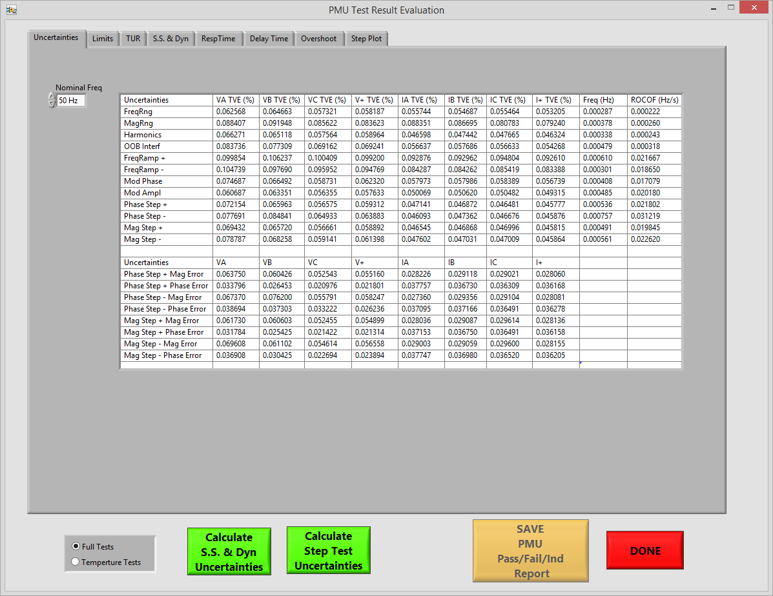

Figure : PMUUncertainty.exe program

When the above program is started, a dialog will appear requesting the user select the folder where the Reports files are saved:

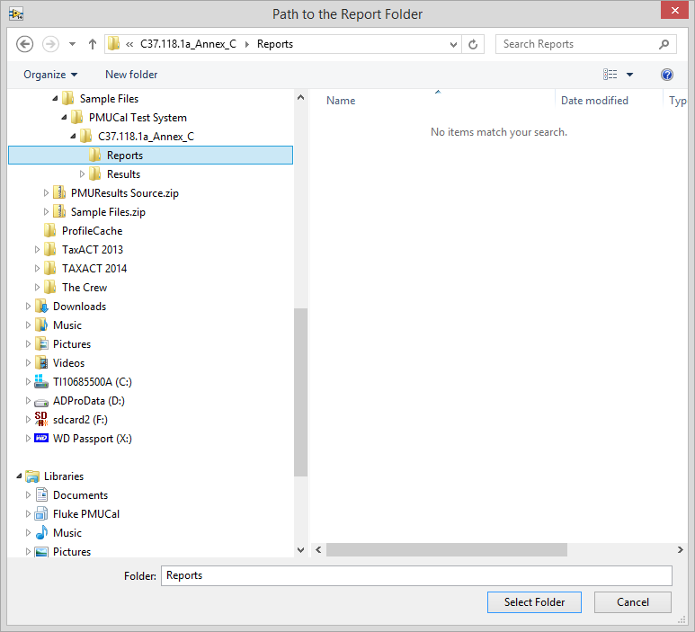

Figure : Select the path to the Reports folder

Once the path is selected, the program will load the PMU calibration uncertainties and the PMU test limits information from it’s own “templates” folders in the Programs Files\PMUUncertainty\Templates folder. Note that the two files: 50Hz_Uncertainties and 60Hz_Uncertainties must be the latest revision files for the PMU calibrator which performed the testing.

The tabs along the top of the program show the results of the calculations done with the program. Once the Reports folder has been selected and the uncertainty and limit information has been loaded, the Uncertainties tab, the Limits and TUR tabs will be fully populated with data.

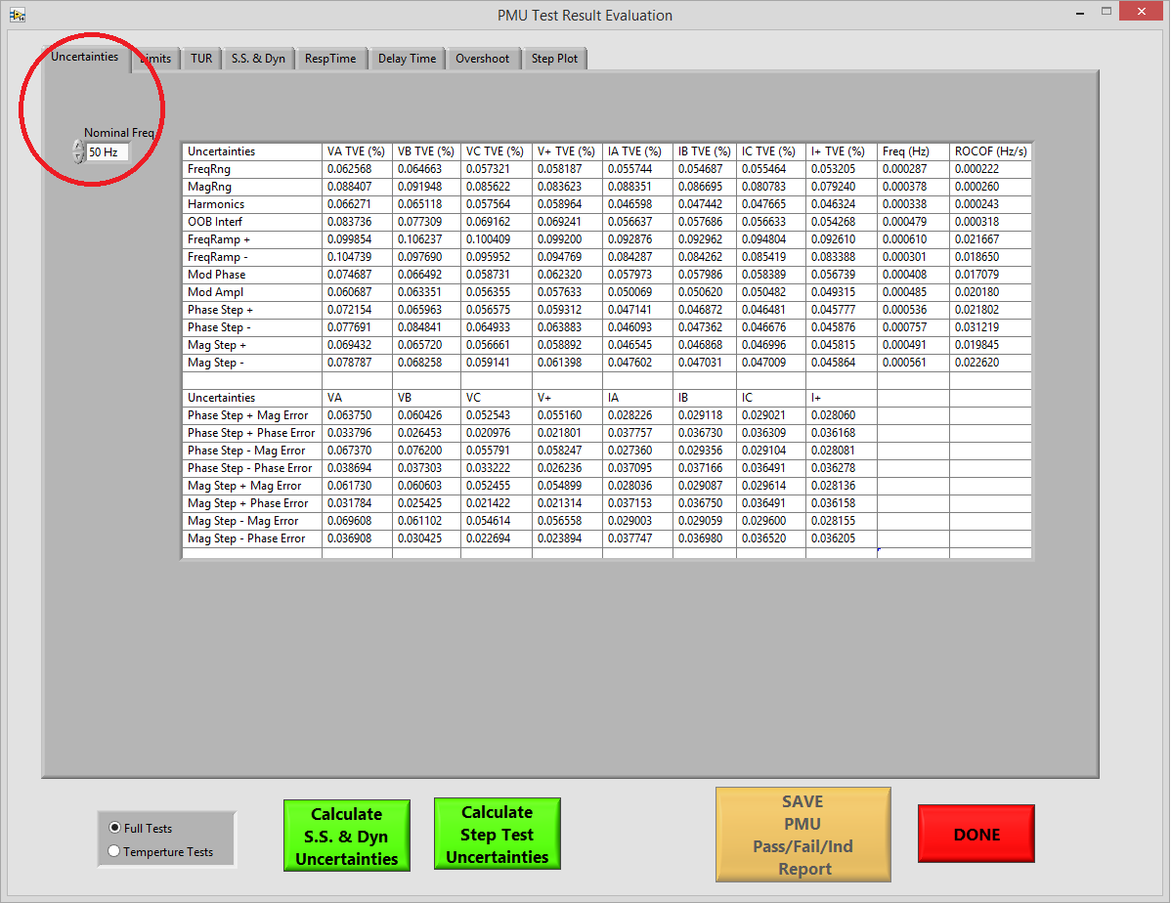

Figure : Uncertainties tab shows the PMU calibration system uncertainties loaded from the uncertainties files

The Nominal Frequency dropdown in the upper left corner of the tab allows the user to display the uncertainties for the PMU calibration system operating at nominal frequency 50 Hz or 60 Hz.

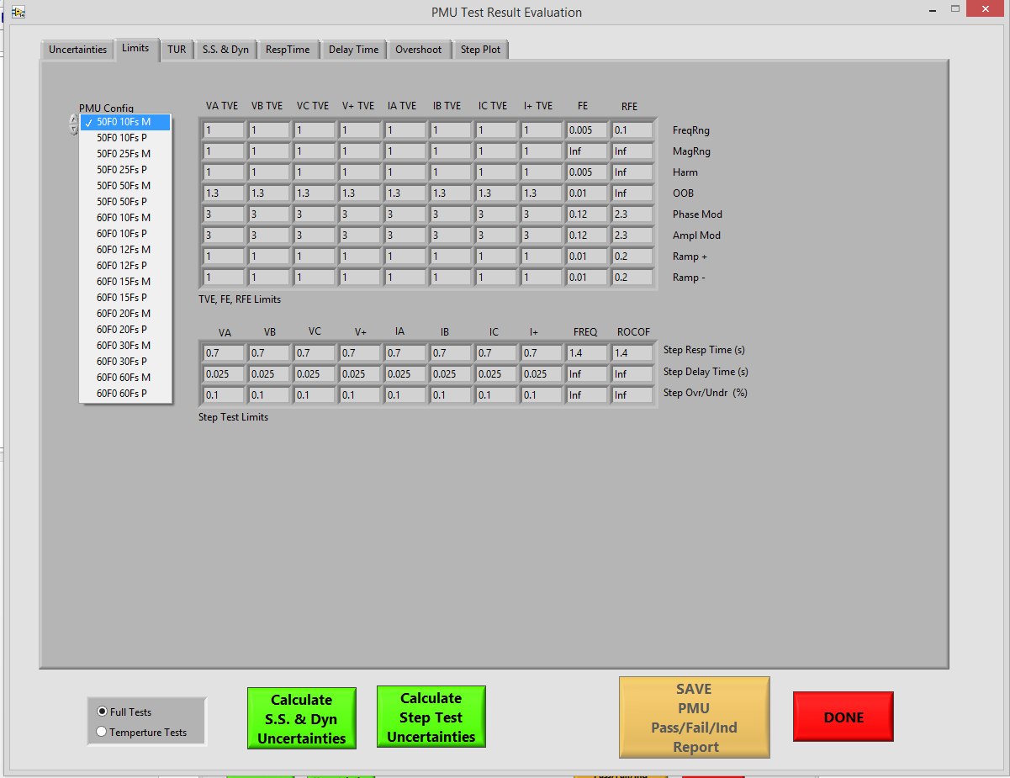

Figure : PMU Uncertainties Limits tab shows the PMU test limits for each of the PMU configurations chosen by the drop-down menu at the upper left-hand corner.

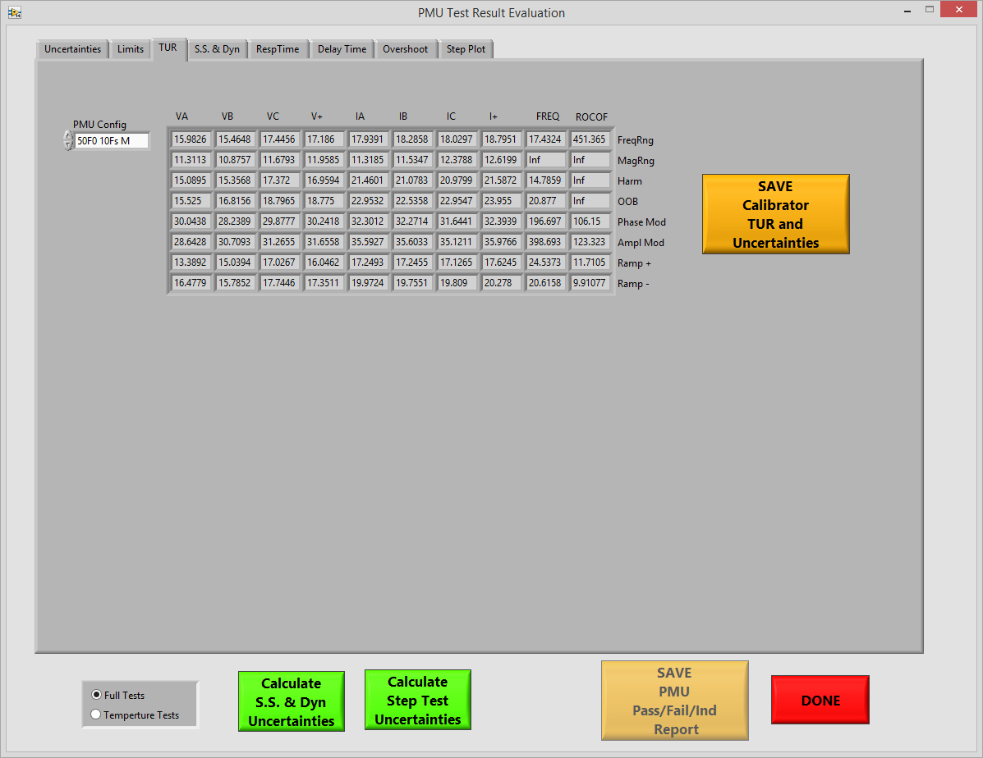

Figure : The TUR tab shows the PMU Calibration system’s test uncertainty ration for each PMU configuration

The TUR tab has a button which can be used to create an EXCEL spreadsheet containing the PMU calibration system’s Uncertainty and TUR for each nominal system frequency and PMU reporting rate.

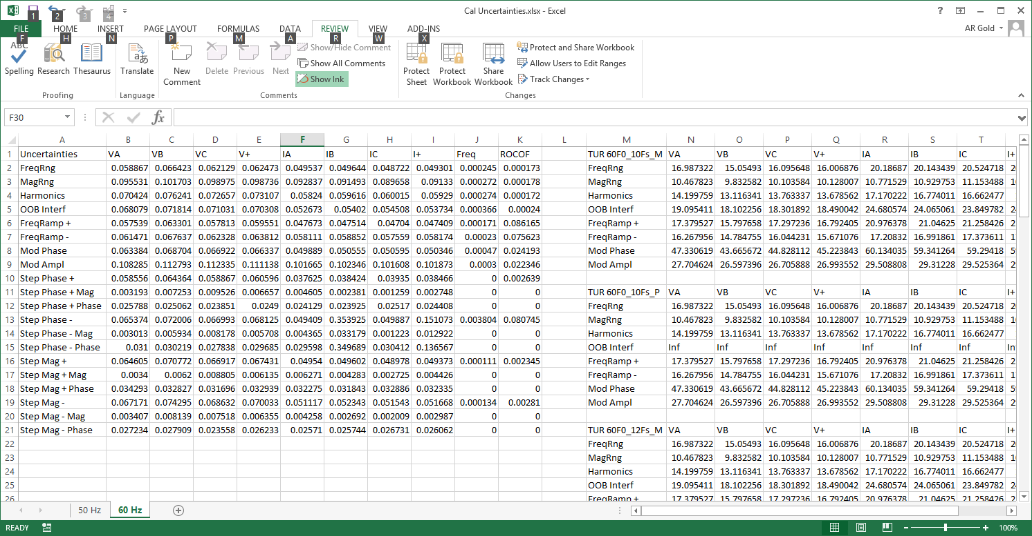

Figure : Calibrator Uncertainties and TUR spreadsheet

In the calibrator uncertainties and TUR spreadsheet, columns A trough K are the measured uncertainties of the calibration system. Columns M through W hold the test uncertainty ratio for each of the PMU configurations (9 rows per configuration).

The uncertainties in rows 2 through 9 and columns B through I are all in units of percent (%) TVE. The Freq and ROCOF columns are in units of Hz and Hz/s respectively. The step tests contain uncertainties in % TVE but the Mag and Phase rows are in percent magnitude an % phase error which are important for determining the uncertainty of the overshoot/undershoot results and of the delay time results.

1. Test result Pass, Fail, Indeterminate (PFI) calculations
   1. Full tests and temperature tests

Two sets of tests are required for PMU certification. A full suite of steady state, dynamic and step tests for each PMU configuration, and a set of steady state frequency range tests taken at 50° C and 0° C. The uncertainty tool has a mode for each test set which is selected by the Full Test / Temperature test radio buttons as shown below:

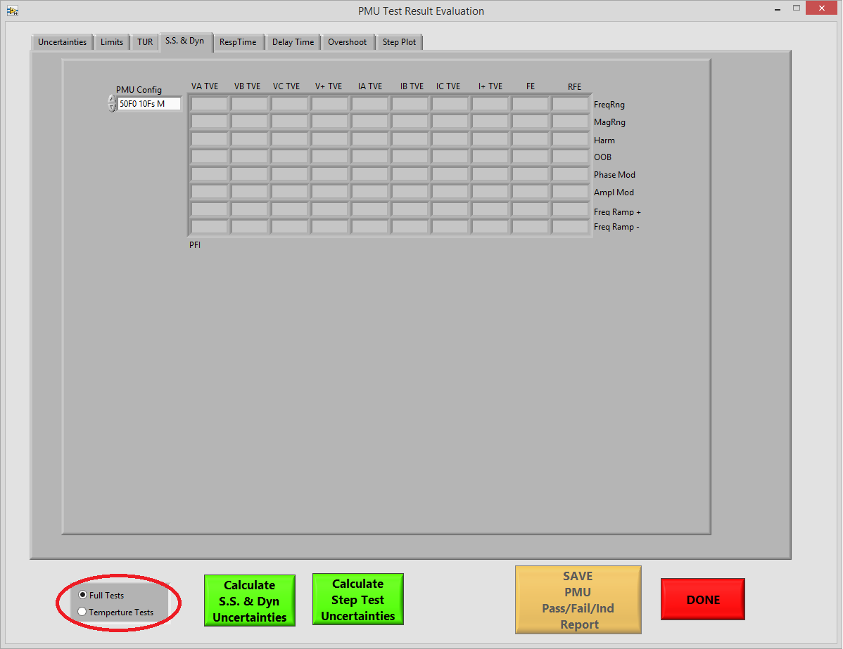

Figure : Radio buttons select the Full or Temperature test types

* 1. Calculating steady state and dynamic test PFI

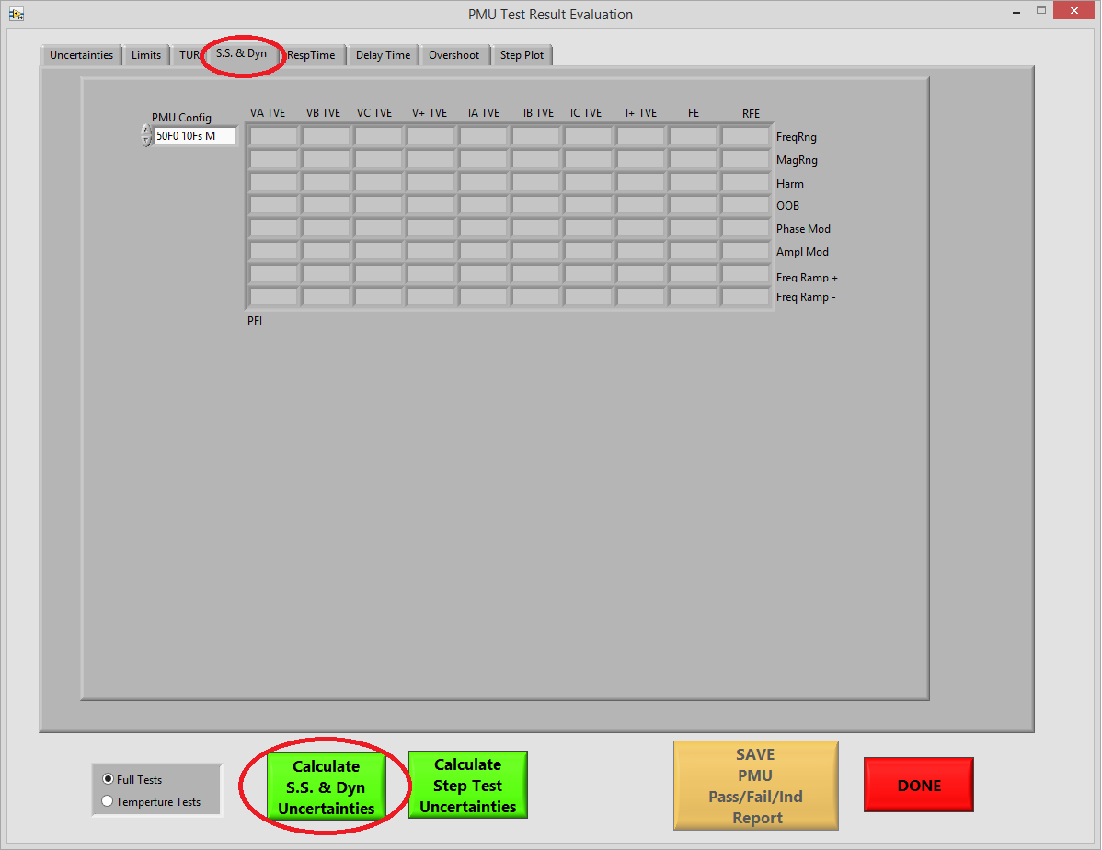

Figure : SS and Dyn tab

The steady state and dynamic tab has no result data until the Calculate SS & Dyn Uncertainties process has been run. This process uses each of the Summary data files found in the Report folder. clicking the Calculate SS & Dyn Uncertainties button launces a dialog which prompts the user to process each of the files using the default filenames.

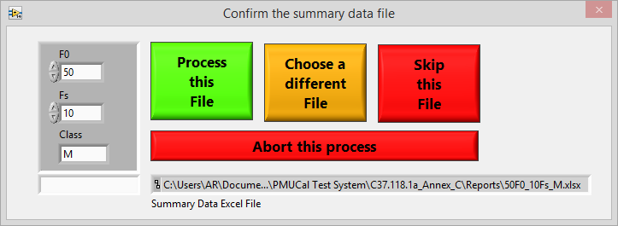

Figure : Dialog to process each of the PMU summary data files.

Click the “Process this File” button for each of the 18 PMU configurations tested. If any of the PMU configurations were not tested, you may choose “Skip this File” If for some reason the file naming does not follow the convention described in section 2.1 (not recommended) a different file name can be chosen. After the 18 configurations have been processed, the table will be filled in with “P” for Pass, “F” for Fail and “I” for indeterminate.

* 1. Calculating the Step Test PFI status and uncertainty ranges

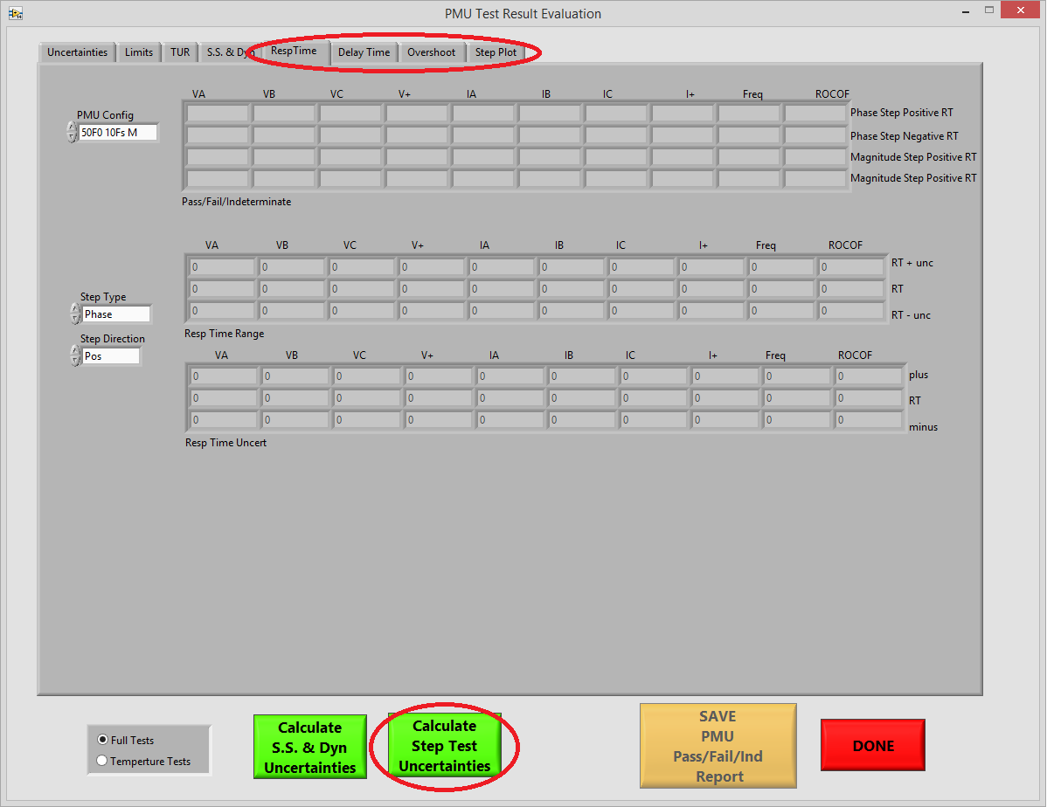

Figure : Step test tabs

The step test uncertainties and Pass, Fail, Indeterminate status is calculated using the “Calculate Step Test Uncertainties” button. Similar to the SS & Dyn calculations, a dialog to process each of the 36 (magnitude and phase step test for each of the 18 PMU configurations, ).

1. Creating PFI Report

Once the Steady State, Dynamic and Step Test PFI and uncertainty data has been calculated, a report can be saved in MS Excel format by clicking on the “Save PMU Pass/Fail/Ind Report” button.

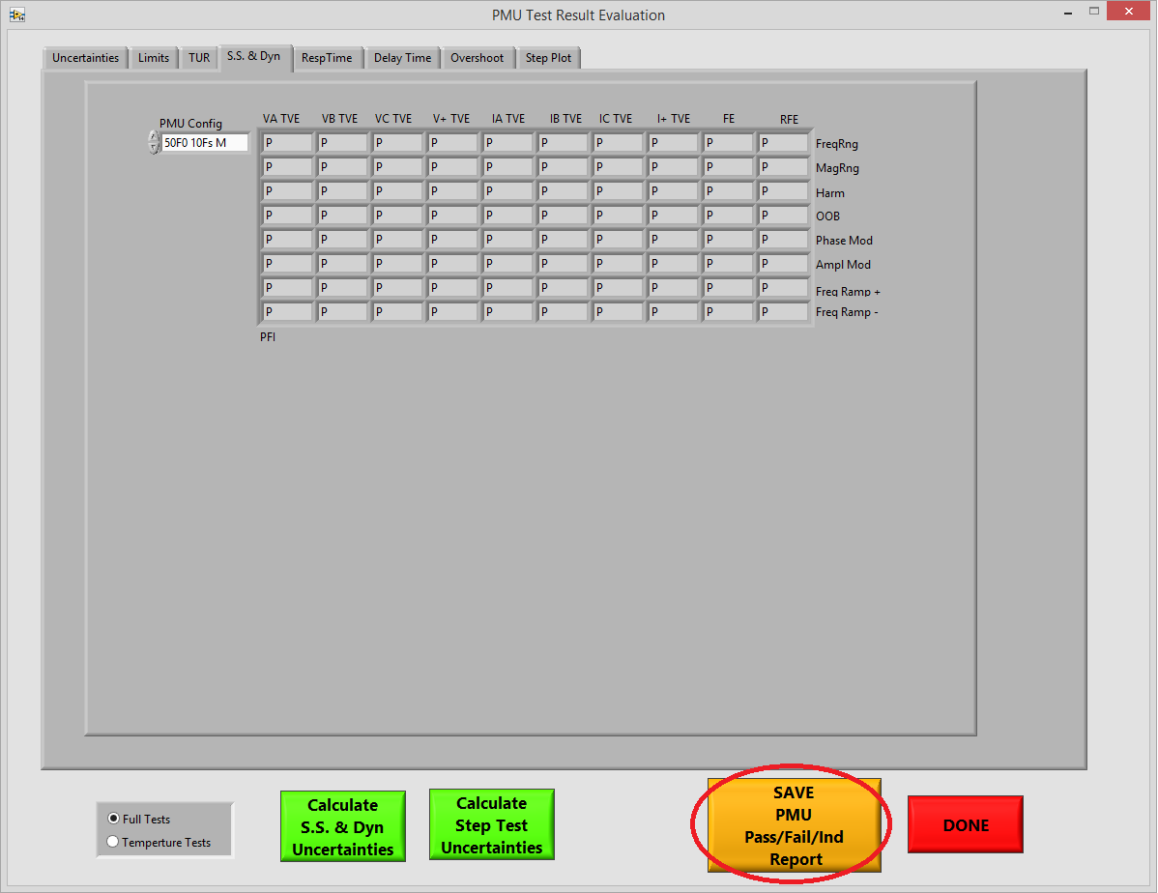

Figure : Save the PFI report

The PFI report has a tab along the bottom for each of the 18 PMU configurations.

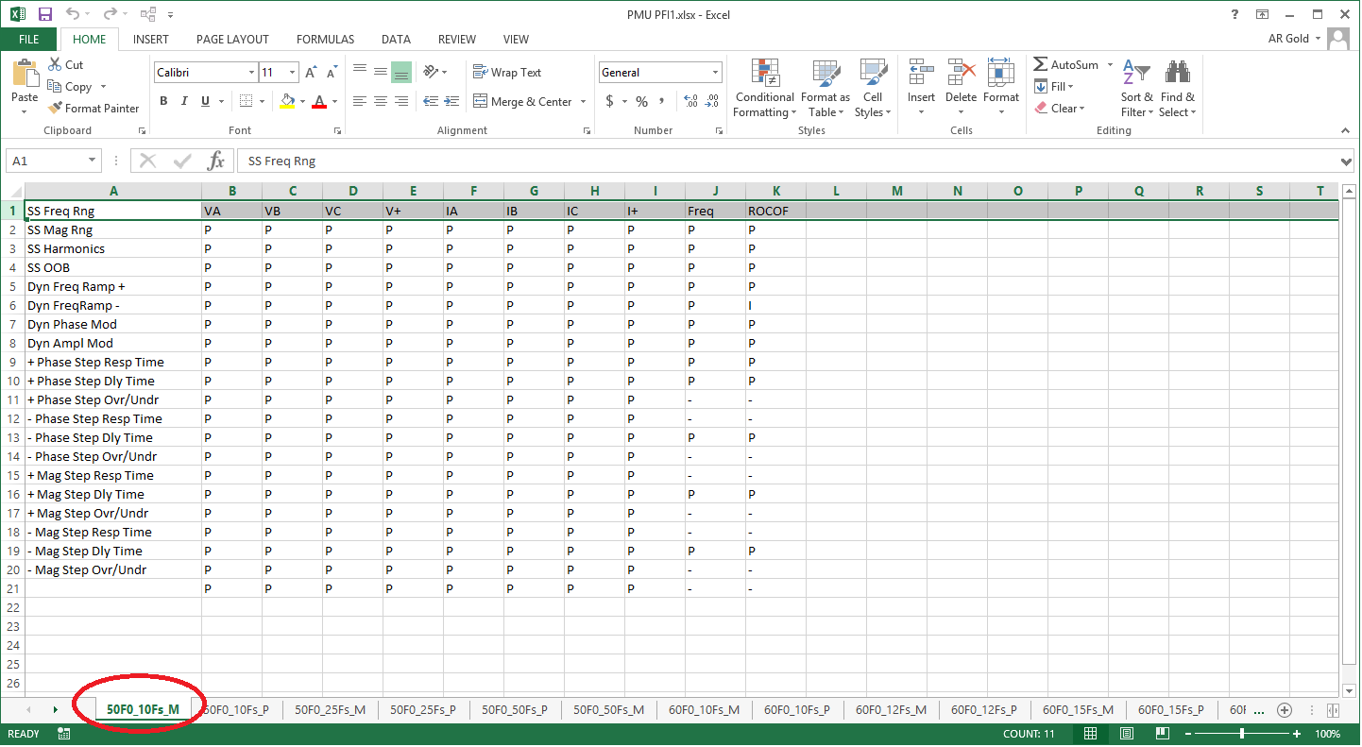

Figure : PMU PFI report

The rows in the report includes each of the steady state and dynamic PFI status including status for both positive and negative frequency ramp tests and positive and negative Phase and Magnitude step tests.

“P” indicates PASS, “F” indicates FAIL, and “I” indicates that the PMU test result was within the PMU calibration systems uncertainty of allowable limit of PMU performance.

1. PMU Calibration system uncertainty and test uncertainty ratio (TUR) report

A report uncertainties of the PMU calibration system used to calibrate the PMU and used to determine the pass, fail, or indeterminate status of each test point can be created using the SAVE Calibrator TUR and Uncertainties button on the TUR tab.

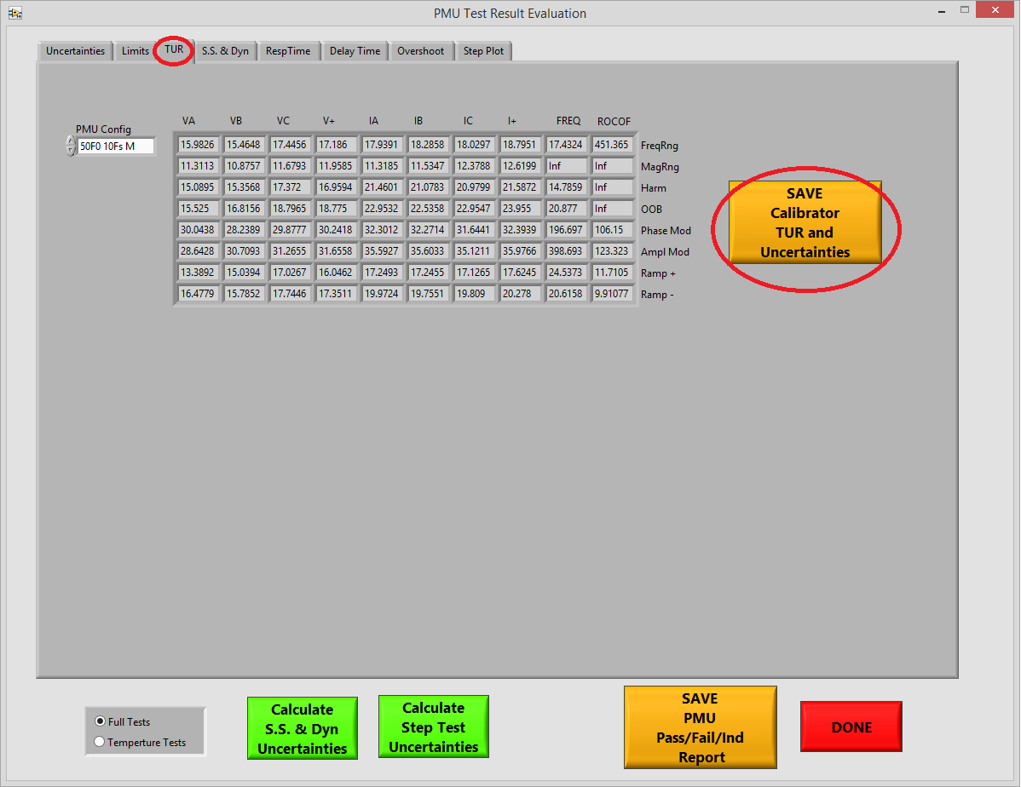

Figure : Save calibrator TUR and Uncertainties report

At the bottom of the excel report are tabs for 50 Hz and 60 Hz uncertainties and TUR. On the top left ate the TVE, FE and RFE uncertainties and on the bottom left are the magnitude and phase error uncertainties used for the step overshoot/undershoot and delay time PFI determination. Along the right side, are test uncertainty ratios for each PMU configuration. The TUR s the ratio of the limits of each test to the PMU calibration system’s uncertainty for that test. 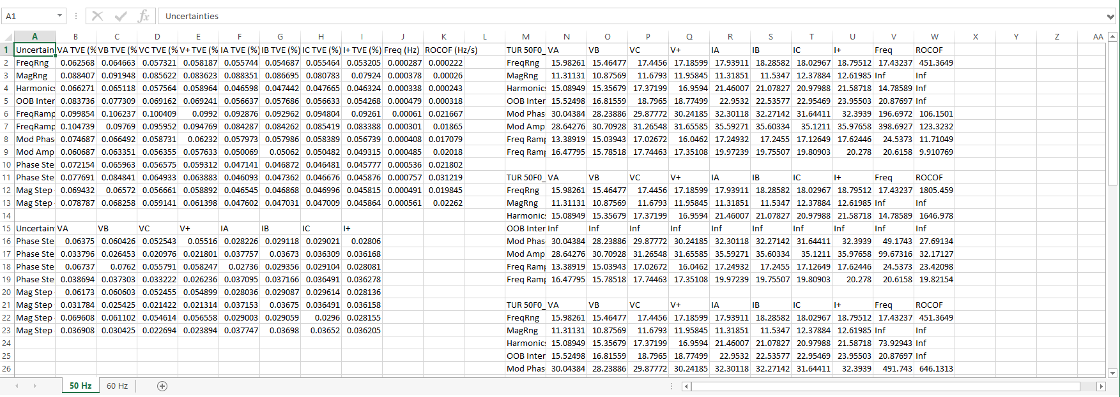

Figure : Calibrator TUR and uncertainties report

1. Troubleshooting and support

There is plenty of error handling built into the tools, but as with any sophisticated programming, not every error event can be handled gracefully. While NIST is under no obligation to continue offering full support for these tools which are offered open source and free of charge, for now, NIST does offer limited support. If you are not able to figure out a work-around for an error, you may contact:

Allen Goldstein  
[allen.goldstein@nist.gov](mailto:allen.goldstein@nist.gov)  
301-975-2101 office/lab  
206-276-7347 cell

# Step Test Uncertainties

Step test metrics are response time, delay time and overshoot/undershoot. In order to determine the uncertainties of these test results, the PMU calibration system TVE, magnitude error, and phase error must be applied to the step test result waveforms. The PMUUncertainty tool provides a Step plot tab where the step test result waveforms can be viewed.

## Response time uncertainties

Response time is the period of time between the first time the TVE, FE, or RFE waveform exceeds a limit until the last time the waveform returns and remains below the limit.

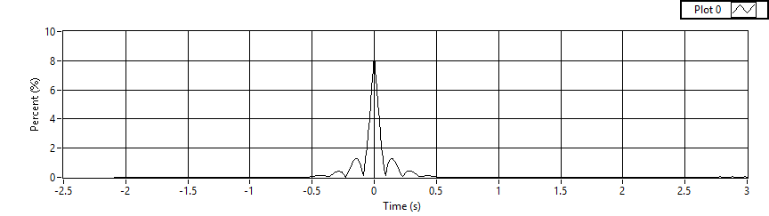

Figure : Step test TVE plot

Figure 18 is a plot of a PMU’s TVE waveform around a 10 degree phase step. Figure 19 zooms in around the step response:

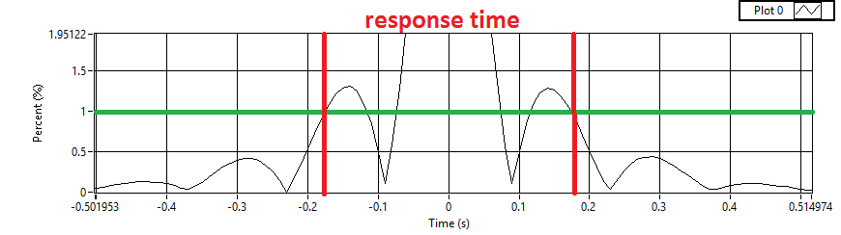

Figure : Phase Step TVE zoom

To determine the uncertainty of the response time, the entire waveform must be shifted p and down by the PMU calibration systems uncertainty and the new response times measured. When shifting the waveform up, the response time will increase and when shifting down, the response time will decrease. The uncertainty is the difference between the shifted response times. It is possible, when the waveform changes direction near the limit, that the response time uncertainties can be quite large.

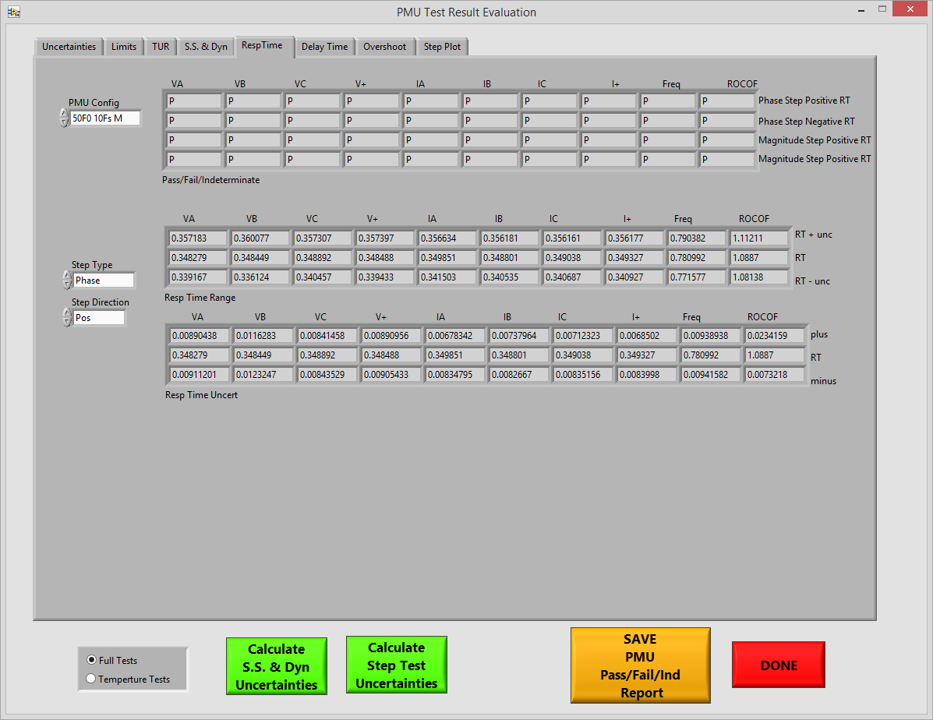

Figure : Step Response Time tab

The Response Time tab shows the step test PFI and also shows uncertainties in two different ways:

1. Response Time Range table shows RT + unc and RT – unc shows the uncertainty added and subtracted from the reported response time and displays them in rows above and below the reported value. For example, the VA response time range in Figure 20 is somewhere from 0.339 s to 0.357 s.
2. Response Time Uncertainty table shows the differences between the reported response time and the added and subtracted uncertainties. for example, the VA response time in Figure 20 is 0.348 +.009, -.009 or 0.348 ± .009.

## Delay time and overshoot/undershoot uncertainty

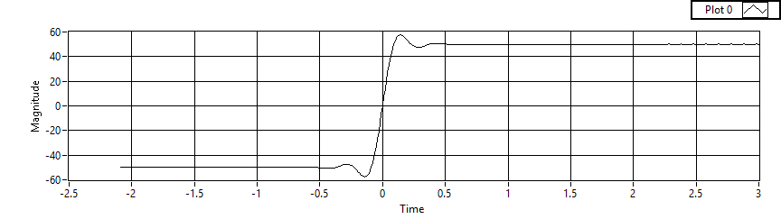

Figure : Step response waveform

Figure 21 shows the waveform for a PMU response to a step in magnitude or phase. The magnitude is shown in percent of the step where 0% is the midpoint of the step response. Determining uncertainty is a matter of shifting the entire waveform up and down by the aunt of the magnitude or phase uncertainty of the PMU calibration system as appropriate.

### Delay time uncertainty

Zooming in on the area where the waveform crosses the 50% level of the step response, marked 0 magnitude on the plot, gives us a close in view of the delay time:

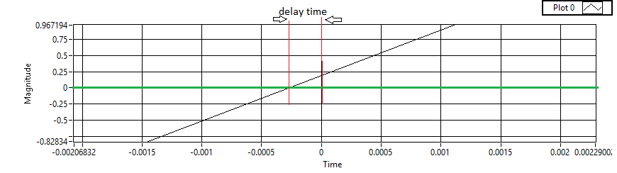

Figure : Delay time uncertainty

The uncertainty is determined by shifting the entire response waveform up and down by the phase or magnitude uncertainty of the PMU calibration system and measuring the delay times of the shifted waveforms.

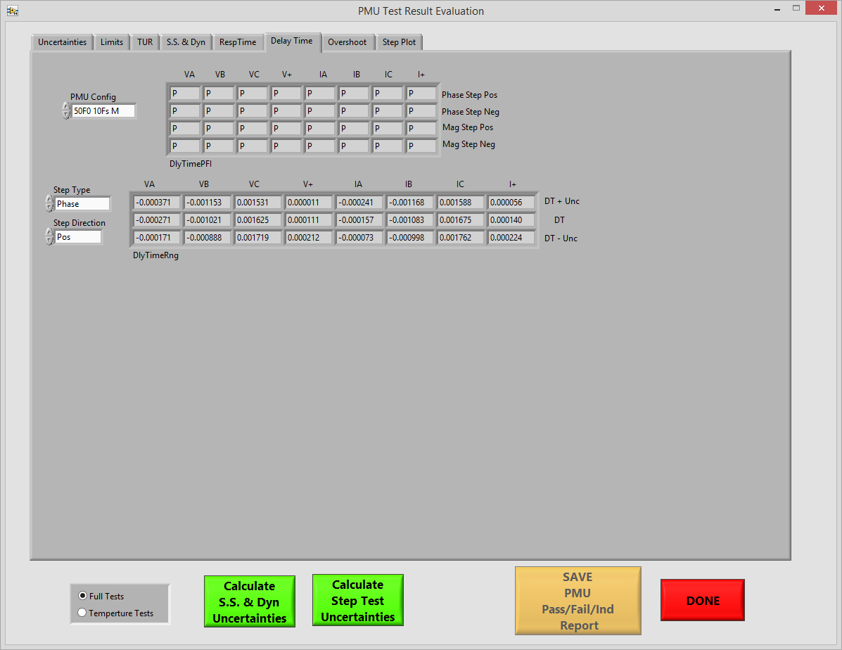

Figure : Delay time uncertainty tab

### Overshoot / Undershoot uncertainty

Overshoot and undershoot are measured by evaluating the phase and magnitude step response waveforms before and after the transition period caused by the step. The maximum difference between the settled value of the waveform and the deviation from the settled value during the pre- and post-step periods is reported as a percentage of the step size. Uncertainties in magnitude and phase are added to and subtracted from the entire waveform to shift it up and down.

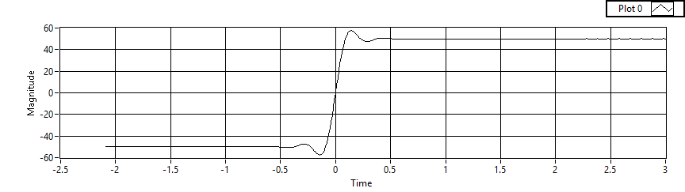

Pre-Step Period

Post-Step Period

post-step overshoot

post-step undershoot

pre-step undershoot

post-step overshoot

Figure : Overshoot / Undershoot

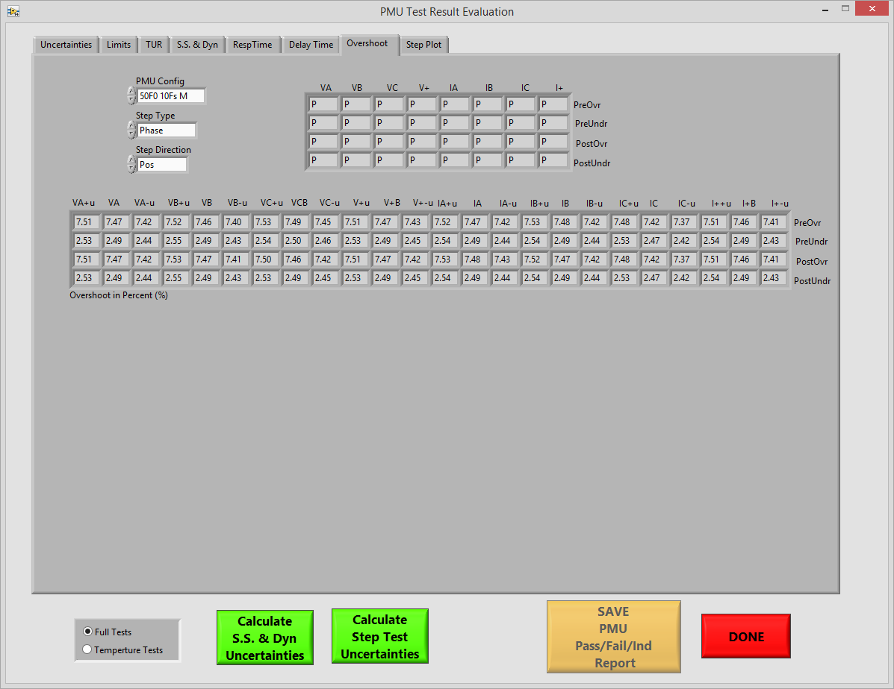

Figure : Overshoot/Undershoot uncertainty tab

The pre-step and post-step overshoot and undershoot is reported and evaluated for the effect of uncertainty. A table on the Overshoot tab of te PMU uncertainty program displays the reported values as well as the reported value with calibration system uncertainty added and subtracted.

## Step test plot tab

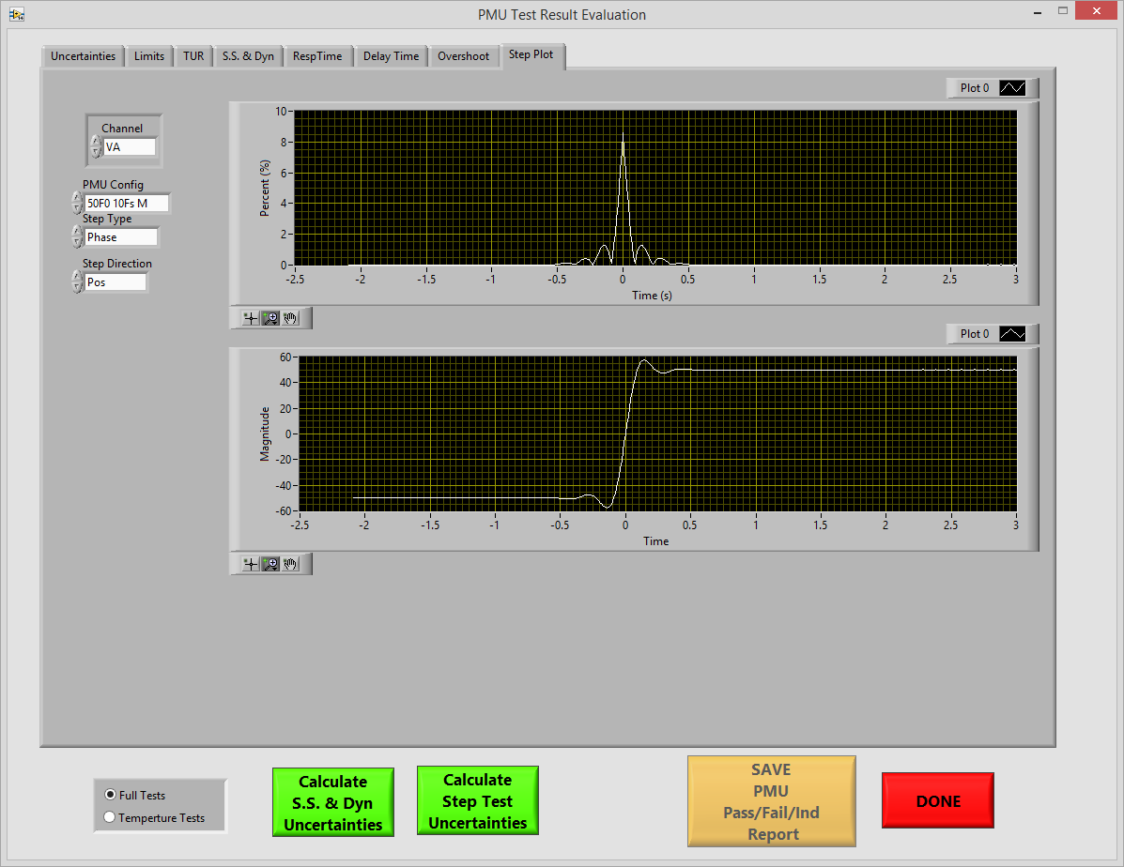

Figure : Step Test Plots

Plots in the PMUUncertainty tool allow for graphical examination of all the step TVE, magnitude, and phase responses.